Membership Operator
Membership operator is used for searching given value exist in collection of values.
Membership is used for collection data type.
Membership operator is binary operator and required 2 operands to perform operation.
Membership operator returns boolean value True/False
Membership operator is represented using 2 keywords

- in
- not in

>>> "a" in "java"
True
>>> "av" in "java"
True
>>> 10 in [100,200,300,400]
False
>>> "nit@gmail.com" in ["naresh@nareshit.com","nit@gmail.com"]
True
>>> "a" in "python"
False
>>> "a" not in "python"
True
>>> "y" not in "python"
False

Example:
# write a program to find input letter is vowel or not

ch=input("input any letter")
print("Vowel") if ch in "aeiouAEIOU" else print("Not Vowel")

Output
input any lettera
Vowel

input any letterI
Vowel
input any letterx
Not Vowel

Bitwise Operators
Bitwise operators perform operations on binary data (0’s and 1’s)
Bitwise operators are applied only on integer data type
Python supports the following bitwise operators

- shift operators
  - left shift operator <<
  - right shift operator >>
- Bitwise & (and) operator
- Bitwise | (or) operator
- Bitwise ^ (XOR) operator
- Bitwise ~ (not) operator

Applications of bitwise operators
- Perform arithmetic operations
- Memory management
- Embedded applications/Low Level Programming
- Encryption and decryption
- Images, audio and video processing

Shift Operators
Shifting operators are binary operators and required 2 operands to perform operations.

Left shift operator <<
This operator is used to shift n bits towards left side.
In left shift operation n bits are added at right side
Left shift operator performs the following arithmetic operation
opr*2 pow n

Syntax: opr<<n

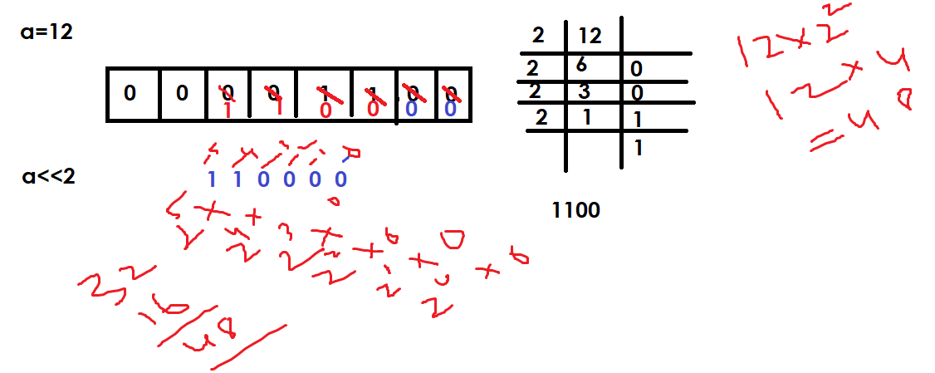
>>> a=12
>>> b=a<<2
>>> print(a,b)
12 48
>>> print(bin(a),bin(b))
0b1100 0b110000
>>> x=0b1100
>>> y=x<<2
>>> print(x,y)
12 48
>>> print(bin(x),bin(y))
0b1100 0b110000
>>> a=0b1
>>> b=a<<2
>>> print(bin(a),bin(b))
0b1 0b100
>>> print(a,b)
1 4

>> Right shift operator
This operator shift n bits towards right side
By shifting n bits right side the bits shifted are deleted
This operator performs the division operation
Opr/2 pow n

Syntax: opr>>n
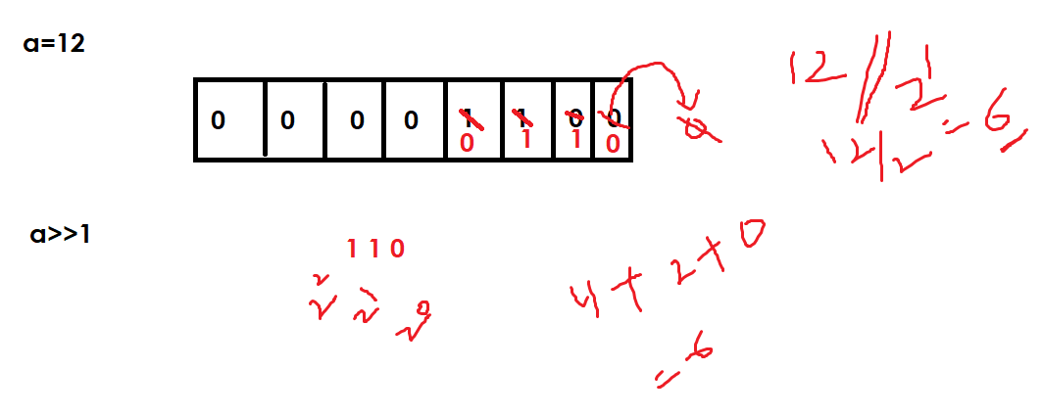

>>> a=12
>>> b=a>>1
>>> print(a,b)
12 6
>>> print(bin(a),bin(b))
0b1100 0b110
>>> x=0b1100
>>> y=x>>2
>>> print(bin(x),bin(y))
0b1100 0b11
>>> print(x,y)
12 3

Bitwise (&) Operator
Bitwise & (and) operator is used to apply and gate
Truth table of & (and) operator

Opr1 | Opr2 | Opr1 & Opr2
1 | 1 | 1
0 | 1 | 0
1 | 0 | 0
0 | 0 | 0

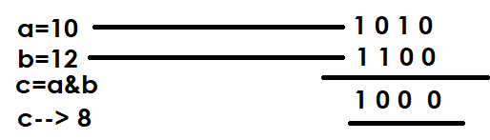
>>> a=10
>>> b=12
>>> c=a&b
>>> print(bin(a),bin(b),bin(c))
0b1010 0b1100 0b1000
>>> x=0b101
>>> y=0b100
>>> z=x&y
>>> print(bin(x),bin(y),bin(z))
0b101 0b100 0b100
>>> print(x,y,z)
5 4 4
>>> a=0xa
>>> b=0xc
>>> c=a&b
>>> print(a,b,c)
10 12 8
>>> print(hex(a),hex(b),hex(c))
0xa 0xc 0x8

Bitwise | (or) operator
This operator is used to apply logical or gate
Truth table or | operator

Opr1 | Opr2 | Opr1|Opr2
0 | 0 | 0
1 | 1 | 1
0 | 1 | 1
1 | 0 | 1
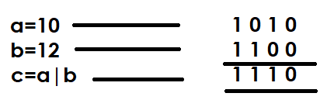

>>> a=10
>>> b=12
>>> c=a|b
>>> print(a,b,c)
10 12 14
>>> print(bin(a),bin(b),bin(c))
0b1010 0b1100 0b1110
>>> x=0b101
>>> y=0b110
>>> z=x|y
>>> print(bin(x),bin(b),bin(z))
0b101 0b1100 0b111
>>> print(x,y,z)
5 6 7

